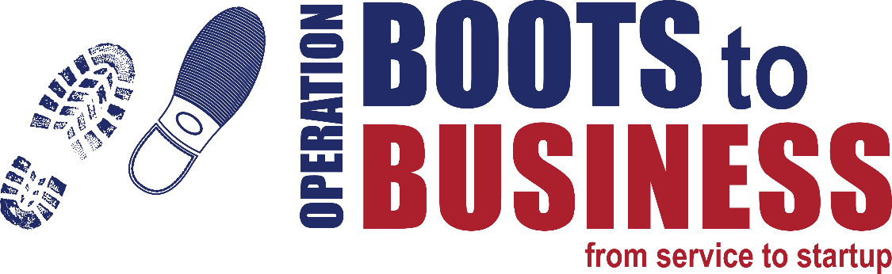
2-DAY REBOOT – November 2-3, 2016

TRAINERS
Reynaldo Vasquez, SBA
David Elizondo, VBOC
Ismael Delgado, VBOC
Juan Santos Flores, VBOC
Lionel Levin, SCORE Chapter 220
Jesse Sanchez, People Fund
Orlando N. Castaneda, PTAC
Alberto Espinoza, SBDC
Yirla Nolan, WBC
RESOURCES
- Introduction to Business Ownership Book
- The Nuts and Bolts to Great Business Plans
- Feasibility Planning Tool
GOALS & OBJECTIVES
- To assist participants in understanding the steps, stages, and activities related to launching and growing a business as a post-military career.
- To help participants understand how business ownership might align (or not) with their own personal strength and life goals.
- To provide introductory training and orientation to the fundamental tools and strategies associated with executing on plans to launch a new business
LOCAL RESOURCES
Small Business Administration (SBA)
SCORE Chapter 220
Procurement Technical Assistance Center (PTAC)
UTRGV Veterans Business Outreach Center (VBOC)
People Fund (Micro Lender)
UTRGV Small Business Development Center (SBDC)
Women’s Business Center (WBC)
TRAINING SCHEDULE
Day One

8:30–9:00 a.m. WELCOME AND INTRODUCTIONS
OBJECTIVE: Provide an overview of the Boots to Business program, the 2-day workshop, and Introduction to Feasibility Analysis.
- Reynaldo Vasquez, SBA
9:00–10:00 a.m. TRAINING MODULE 1: INTRODUCTION TO BUSINESS OWNERSHIP
OBJECTIVE: Provide an overview of the entrepreneurial process, what it means to be an entrepreneur, the opportunities and challenges and military skills and attributes that transfer over to entrepreneurship.
- David Elizondo, VBOC Director
10:00–11:00 a.m. TRAINING MODULE 2: RIGHT IDEA? BASICS OF OPPORTUNITY RECOGNITION
OBJECTIVE: Describe the process and activities related to understanding the ‘business case’ for turning an idea into a sustainable business concept.
- Yirla Nolan, WBC Director
11:00–11:15 a.m. BREAK

11:15–12:00 p.m. APPLIED ACTION SESSION (I)
OBJECTIVE: Apply conceptual training (Opportunity Recognition) to personalized feasibility plan.
- Yirla Nolan, WBC Director
12:00–1:00 p.m. LUNCH
1:00–2:00 p.m. TRAINING MODULE 3: UNDERSTANDING MARKETS & YOUR COMPETITIVE SPACE
OBJECTIVE: Understand how to conduct market research, the importance of market research, and also the basics of competitive strategy/analysis.
- Alberto Espinoza, SBDC Business Outreach Specialist
2:00–2:30 p.m. APPLIED ACTION SESSION (II)
OBJECTIVE: Apply conceptual training (Markets & Competition) to personalized feasibility plan.
- Alberto Espinoza, SBDC Business Outreach Specialist
2:30–2:45 p.m. BREAK

2:45–3:45 p.m. TRAINING MODULE 4: THE ECONOMICS OF SMALL BUSINESS START-UP
OBJECTIVE: Understand the foundation for the cost, price, volume relationship, as it informs profit potential and sustainability for the planned venture.
- Ismael Delgado, UTRGV/VBOC Business Advisor
3:45–4:15 p.m. APPLIED ACTION SESSION (III)
OBJECTIVE: Apply conceptual training (Economics) to personalized feasibility plan.
- Ismael Delgado, UTRGV/VBOC Business Advisor
4:15–4:40 p.m. CLOSING REMARKS AND INSTRUCTIONS
- Reynaldo Vasquez, SBA
TRAINING SCHEDULE
Day 2

8:30–8:45 a.m. OPENING REMARKS
- Reynaldo Vasquez, SBA
8:45–9:45 a.m. MODULE 5: PICKING THE CORRECT LEGAL ENTITY FOR YOUR BUSINESS
OBJECTIVE: Understand the various legal forms of a business; opportunities and challenges associated with each; offer an overview of other legal considerations impacting veteran-owned business; government contracting.
- Lionel Levin, SCORE Chapter 220
9:45–10:00 a.m. BREAK
10:00–11:00 a.m. MODULE 6: FINANCING YOUR VENTURE
OBJECTIVE: Understand the resources required to execute on your venture concept; understand the different opportunities to fund start-up and subsequent growth; opportunities and challenges associated with each.
- Jesse Sanchez, PeopleFund
11:00–11:30 a.m. APPLIED ACTION SESSION (IV)
OBJECTIVE: Apply conceptual training (Legal & Financing) to personalized feasibility plan.
- Jesse Sanchez, PeopleFund
11:30–12:30 p.m. LUNCH
12:30–1:30 p.m. MODULE 7: NEXT STEP – INTRODUCTION TO BUSINESS PLANNING
OBJECTIVE: Leveraging the Nuts & Bolts Guide to Business Planning, understand how to move from feasibility analysis to constructing a viable and fundable business plan.
- Juan Santos Flores, VBOC Business Advisor
1:30–2:00 p.m. APPLIED ACTION SESSION (V)
OBJECTIVE: Apply conceptual training (Business Planning) to personalized feasibility plan.
- Juan Santos Flores, VBOC Business Advisor
2:00–2:15 p.m. BREAK
2:15–3:15 p.m. MODULE 8: MOVING FORWARD: RESOURCES TO SUPPORT YOU
OBJECTIVE: Understand the resources available through the SBA, VA, and other resource partners positioned to provide future training and support of the participant’s efforts to launch and grow a sustainable business venture.
- Reynaldo Vasquez, SBA
- Reynaldo Soto, PTAC
3:15–3:30 p.m. APPLIED ACTION SESSION (VI)
OBJECTIVE: Apply conceptual training (Personal Support Plan) to personalized feasibility plan.
- Reynaldo Vasquez, SBA
3:30–4:00 p.m. GROUP QUESTION/ANSWER SESSION/CLOSING REMARKS
- Reynaldo Vasquez, SBA

